An Advanced Autism Detection and Therapy Recommendation System
Abstract:

The objective of this project is to develop an autism detection system that leverages diverse data sources to provide accurate and holistic assessments. The final implementation comprises three key components:

1. Tabular Data Model:
- The first component involves the creation of a model that analyzes tabular data. This model is designed to assess various attributes and factors associated with autism risk, contributing to a comprehensive evaluation.

2. Image/Video Data Model:
- The second component is an image data/ Video data model that processes video input to classify children as either autistic or non-autistic By utilizing image-based information, this model enhances the accuracy and depth of the assessment.

3. Integration of Models:
- The project integrates both the tabular data model and the image/ Video data model to provide a balanced and averaged prediction. This combined approach leverages the strengths of each model to deliver a more robust and reliable outcome.

4. Therapy Recommendations:
- Based on the results obtained from the assessment, the system offers personalized therapy recommendations. These recommendations are tailored to the individual's Autism Spectrum Quotient (ASQ) score, providing targeted guidance for therapy and support.

This multi-faceted approach to autism detection aims to improve accuracy and enhance the understanding of each child's unique needs, ultimately facilitating early intervention and support for those on the autism spectrum.

The Autism Detection Project extends its scope to include the development of an Android application that enhances accessibility and user-friendliness. In addition to the previously mentioned components, the project now incorporates the following aspects:

5. Android Application Development:
- The project includes the creation of an Android application using Android Studio. This application serves as a user-friendly interface for individuals seeking autism assessments and therapy recommendations.

6. Server Implementation:
- A server application is established on a laptop to provide the necessary backend functionalities for the Android app. This server facilitates data processing, communication with the models, and the delivery of assessment results and therapy recommendations to the app.

7. Seamless App-Server Interaction:
- The Android app seamlessly connects to the server, enabling real-time communication and data exchange. Users can input information, submit video data, and receive assessment results and therapy recommendations directly through the app.

By introducing an Android application and server infrastructure, this project aims to democratize access to autism detection and support services. Users can conveniently utilize the app to assess autism risk and receive personalized therapy guidance, enhancing early intervention and support for individuals on the autism spectrum.

Introduction

In an era of ever-evolving technology and healthcare, the quest for early detection and intervention in autism spectrum disorder (ASD) has gained significant importance. Our project, the Autism Detection System, aims to leverage cutting-edge technology to create a comprehensive solution for ASD assessment and support.

Autism spectrum disorder is a complex neurodevelopmental condition that affects individuals in various ways. Early detection and intervention are crucial for improving the quality of life for those affected by ASD. To address this challenge, we have devised an innovative multi-faceted approach.

Our final implementation consists of several key components:

1. Tabular Data Model: We employ a model that utilizes tabular data, which includes essential information related to the child's development and behavioral patterns. This model will analyze structured data to make predictions regarding the likelihood of ASD.

2. Image/ Video Data Model: To enhance our detection capabilities, we incorporate an image/ Video data model. This model accepts video input and can distinguish between autistic and neurotypical children based on visual cues and behavioral patterns captured in the video.

3. Integration of Models: The synergy of both the tabular and image/ Video data models allows us to provide a comprehensive assessment. By integrating these models, we obtain an average prediction that combines insights from both data sources, offering a more robust evaluation of ASD risk.

4. Therapy Recommendations: Beyond detection, our system goes a step further by providing personalized therapy recommendations based on the results. We suggest 3-4 selected therapy options tailored to the child's ASD assessment scores, ensuring a holistic approach to support and intervention.

Moreover, our commitment to accessibility and usability extends to the development of an Android application. This app will serve as a user-friendly interface, connecting seamlessly to a server running on a laptop. This server-app connection allows parents, caregivers, and healthcare professionals to access the system's functionalities conveniently.

In summary, the Autism Detection System is a pioneering project that leverages technology, data analysis, and artificial intelligence to detect autism spectrum disorder early and provide actionable recommendations for intervention. Through the integration of multiple models and the development of a user-friendly Android app, we aim to make a meaningful impact on the lives of children and families affected by ASD.

Block Diagram:
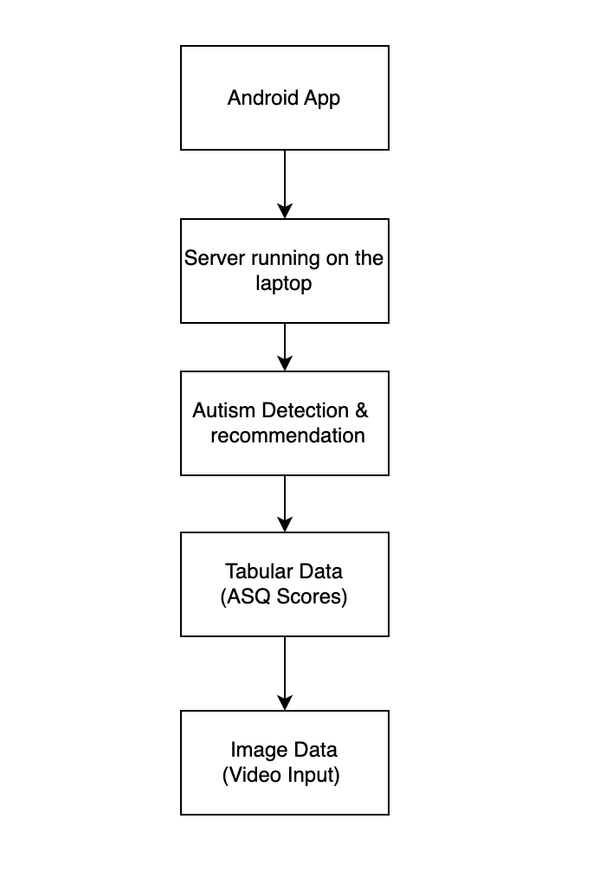
Architecture Diagram:
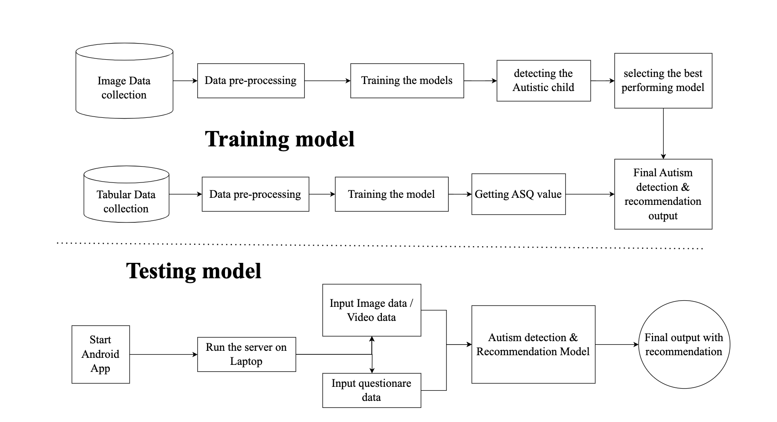
Use-case Diagram:

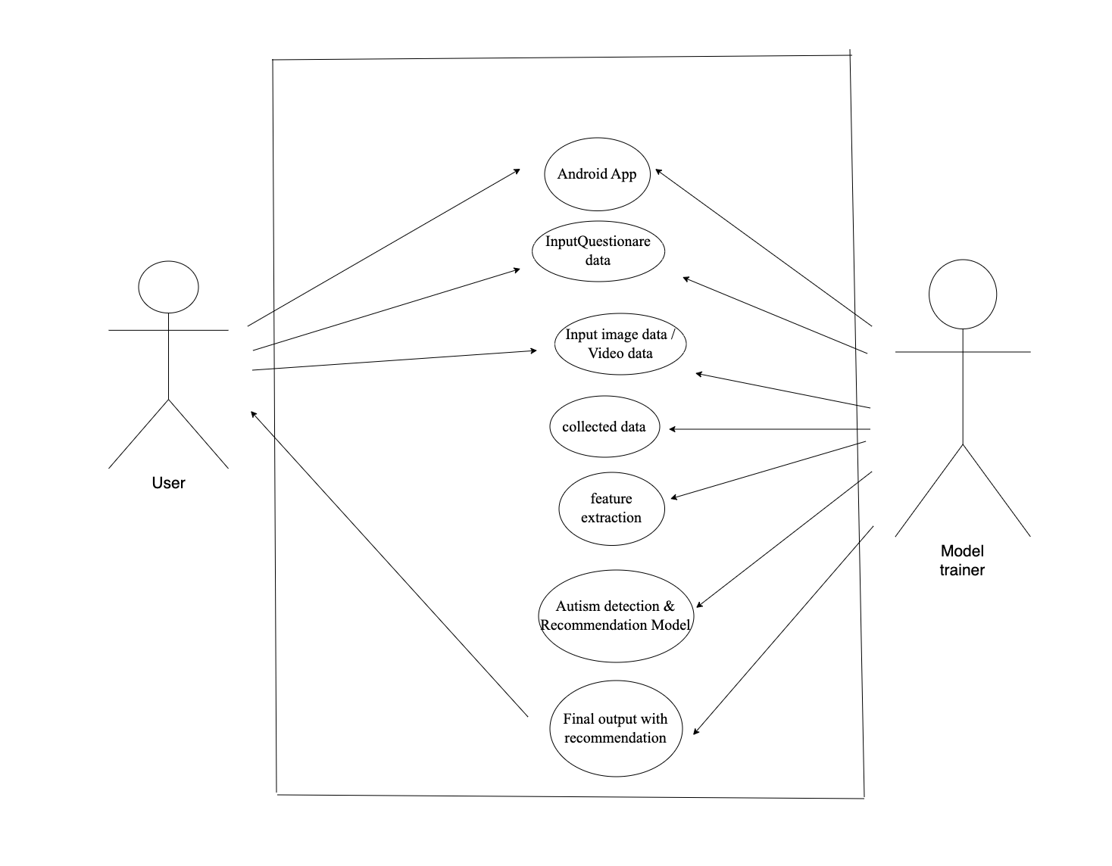
Proposed System: An Advanced Autism Detection and Therapy Recommendation System

Our proposed system represents a cutting-edge solution for the detection of autism spectrum disorder (ASD) in children and offers personalized therapy recommendations. Leveraging the power of modern technology, our system combines multiple data sources, advanced machine learning models, and mobile application integration to create a comprehensive and user-friendly platform.

Key Features and Innovations:

1. Multimodal Approach: Our system employs a multimodal approach, combining tabular data and image data for more accurate and reliable autism detection. This dual-model approach enhances the robustness and precision of our system.

2. Deep Learning Models: We utilize state-of-the-art deep learning models for both tabular and image/ Video data. These models have been trained on extensive datasets, enabling them to recognize subtle patterns and indicators of autism with high accuracy.

3. Integration of Models: The synergy between the tabular and image-based models is achieved through intelligent integration. By combining the predictions of these models and calculating an average, we provide a well-rounded and more reliable assessment of a child's condition.

4. ASQ Score-Based Recommendations: Our system assesses children's Autism Screening Questionnaire (ASQ) scores and generates tailored therapy recommendations. These recommendations are drawn from a curated selection of evidence-based therapies, ensuring that each child receives personalized care.

5. Android Application: To make our system accessible and user-friendly, we develop an Android mobile application. Parents, caregivers, and healthcare professionals can easily input data, view results, and access therapy recommendations on their smartphones or tablets.

6. Server-App Interaction: The server component, running on a laptop or a designated machine, communicates with the Android app to provide functionalities such as data analysis, prediction, and therapy recommendations. This server-based architecture ensures the processing power required for complex tasks.

Existing Systems: A Comparative Overview

While several existing systems address autism detection and therapy recommendation, our proposed system distinguishes itself through innovation, integration, and user-friendliness:

1. Traditional Screening Tools: Many existing systems rely solely on traditional screening tools and questionnaires, which can lack the accuracy and predictive power of advanced machine learning models.

2. Limited Data Sources: Some systems rely exclusively on a single data source, either tabular data or image data. Our system's multimodal approach provides a more comprehensive view of a child's condition.

3. Manual Therapy Selection: Existing systems often require healthcare professionals to manually select therapy recommendations based on assessment results. Our system automates this process, providing data-driven, personalized recommendations.

4. User Accessibility: Many existing systems lack user-friendly interfaces, making them less accessible to parents and caregivers. Our Android application ensures easy access and data input.

5. Integration: Our system integrates all components seamlessly, offering a unified platform for assessment and therapy recommendations. This integration streamlines the process and enhances user experience.

In conclusion, our proposed system represents a significant advancement in the field of autism detection and therapy recommendation. By combining advanced technology, data integration, and user accessibility, we aim to provide a valuable tool for early diagnosis and intervention in autism spectrum disorder, ultimately improving the lives of children and their families.

Software Requirements:

Python
Visual Studio Code
PyTorch or TensorFlow for deep learning
OpenCV for computer vision tasks
Scikit-learn for machine learning
Pandas for data manipulation
Flask or Django for web development (if required)
Android Studio for mobile app development (if required)

Hardware Requirements:

RAM (16 GB or more)
Processor (CPU): Intel Core i7

Models:

Advanced Convolutional Neural Network (CNN) architectures

VGG: VGG is known for its simplicity and effectiveness. It consists of multiple layers with small 3x3 convolutional filters and max-pooling layers. VGG architectures, such as VGG16 and VGG19, have a deep and uniform structure, making them easy to understand and modify. They excel at feature extraction and have been influential in image classification tasks.

ResNet: ResNet introduced the concept of residual connections, which address the vanishing gradient problem in deep networks. By using skip connections that allow information to flow directly through layers, ResNet can train very deep networks effectively. This architecture has had a significant impact on deep learning and has been used extensively in various image recognition and other computer vision tasks.

Both VGG and ResNet have played pivotal roles in advancing the state-of-the-art in image analysis and continue to be essential building blocks in deep learning models.

Methodology

The methodology for the project titled "Advanced Autism Detection and Therapy Recommendation System" involves a multi-faceted approach that combines data analysis, machine learning, image processing, and mobile application development. Below is a detailed explanation of the methodology:

1. Data Collection and Preprocessing:
- Gather two types of datasets: tabular data containing attributes related to autism risk and image data comprising videos of children for classification.
- Preprocess the tabular data by handling missing values, encoding categorical variables, and scaling numerical features.
- Prepare the image data by extracting frames from videos and converting them into a suitable format for model input.

2. Tabular Data Model:
- Develop a machine learning model (e.g., Random Forest, Decision Tree, AdaBoost) to analyze the tabular data.
- Train the model using the preprocessed tabular dataset to predict autism risk.
- Perform hyperparameter tuning to optimize model performance.
- Evaluate the model's accuracy, precision, recall, and F1-score using cross-validation techniques.

3. Image/ Video Data Model:
- Create a deep learning model (e.g., Convolutional Neural Network - CNN) to process image/ Video data from video frames.
- Train the CNN model to classify children as autistic or non-autistic based on image-based information.
- Fine-tune the model's hyperparameters and architecture for better performance.
- Assess the model's accuracy, sensitivity, and specificity on a validation set.

4. Integration of Models:
- Combine the predictions from the tabular data model and the image data model.
- Develop an integration algorithm that takes into account the strengths of each model and produces a balanced and averaged prediction.

5. Therapy Recommendations:
- Utilize the combined assessment results to calculate the Autism Spectrum Quotient (ASQ) score for each individual.
- Design a recommendation system that provides personalized therapy recommendations based on the ASQ score.
- These recommendations are tailored to the specific needs and characteristics of the child.

6. Android Application Development:
- Create an Android application using Android Studio to enhance accessibility and user-friendliness.
- The app provides an intuitive interface for users seeking autism assessments and therapy recommendations.
- Users can input information, record and submit video data, and receive assessment results and therapy guidance.

7. Server Implementation:
- Establish a server application on a laptop to serve as the backend infrastructure for the Android app.
- The server handles data processing, communication with the models, and the delivery of assessment results and therapy recommendations.
- It ensures real-time interactions between the app and the models.

8. Seamless App-Server Interaction:
- Enable seamless communication between the Android app and the server.
- Users can input data via the app, submit video recordings for assessment, and receive real-time results and therapy recommendations from the server.

9. User Testing and Feedback:
- Conduct user testing to evaluate the Android app's usability, user interface, and overall performance.
- Gather feedback from users and make necessary improvements to enhance the user experience.

10. Deployment and Accessibility:
- Deploy the Android app on a user-friendly platform such as the Google Play Store.
- Ensure accessibility for a wide range of users, including parents, caregivers, and healthcare professionals.

By following this comprehensive methodology, the project aims to develop a sophisticated Autism Detection and Therapy Recommendation System that leverages the power of data analysis, machine learning, and mobile technology to enhance early intervention and support for individuals on the autism spectrum.

Model development

Model development in this project involves the creation of two types of models: tabular data models and image data models. Each type of model serves a distinct purpose and leverages different machine learning techniques. Let's explore these two aspects of model development in detail:

Tabular Data Models:

1. Data Preprocessing:
- The tabular dataset contains structured data with various attributes related to autism risk, such as demographic information, medical history, and behavioral traits.
- Data preprocessing is performed to clean and prepare this tabular dataset. This includes handling missing values, encoding categorical variables into numerical format (e.g., one-hot encoding), and scaling numerical features.

2. Model Selection:
- Traditional machine learning models such as Random Forest, Decision Trees, and AdaBoost are chosen for this type of data.
- These models are well-suited for tabular data and can handle a mix of categorical and numerical features.

3. Training and Evaluation:
- The preprocessed tabular dataset is split into training and testing sets.
- The selected machine learning models are trained using the training data.
- Hyperparameter tuning is performed to optimize the models' performance.
- Evaluation metrics such as accuracy, precision, recall, and F1-score are computed on the testing set to assess the models' predictive capabilities.

Image Data Models:

1. Data Preprocessing:
- The image dataset comprises video frames of children, which need to be processed to extract relevant information for model input.
- Video frames are converted into a suitable format for deep learning models. This often involves resizing, normalization, and data augmentation to increase the diversity of training examples.

2. Model Selection:
- Deep learning models, specifically Convolutional Neural Networks (CNNs), are chosen for processing image data.
- Models like RESNET and VGG, known for their effectiveness in image classification tasks, are utilized.
- Transfer learning may also be employed, where pre-trained CNN models are fine-tuned on the project's specific dataset.

3. Training and Evaluation:
- The image data is divided into training, validation, and testing sets.
- The selected CNN models are trained using the training data. During training, the models learn to recognize patterns and features that distinguish autistic and non-autistic children.
- Hyperparameter tuning and fine-tuning of the models are carried out to achieve the best performance.
- The performance of the image data models is assessed using evaluation metrics, with a focus on accuracy, sensitivity, and specificity.

Integration of Models:

1. Once the tabular data models and image data models are developed and evaluated independently, their predictions are integrated.
2. An integration algorithm is designed to consider the strengths and weaknesses of each model and produce a unified prediction.
3. By combining the outputs of both types of models, the project aims to provide a more balanced and reliable assessment of autism risk.

In summary, the project employs a hybrid approach to model development, utilizing traditional machine learning models for tabular data and deep learning CNN models for image data. The integration of these models ensures a comprehensive evaluation of autism risk, enhancing the accuracy and depth of the assessment.

